TOWERS

PAPER TOWERS

Type of Contest: Team
Composition of Team: 1-2 students team

Overview: To build the tallest freestanding tower possible from a single sheet of 20 lb. paper.

Materials (per team):
- One piece of 8.5” x 11” 20 lb.
- One piece of scotch tape 0.5 in x 1 foot scotch tape
- Scissors
- Ruler
- Pencil

Rules:

- Each tower must be constructed from the paper and tape supplied by the Host Center. No materials or substitutions are allowed.

- Contestants have a 45-minute period in which to construct their towers. Any modifications made to tower after the allotted 45-minute period will disqualify the tower. Late arriving students may enter the contest at any time after the 45-minute period has begun, however, they must stop when everyone else stops. No extra time will be allotted to late starters.

- Each tower must be freestanding; it must not be attached to or lean against any other surface (e.g. floor, wall, desk, etc…)

- Towers must stand for 10 seconds upon arrival of a judge.

- During the contest, all students shall have equal access to all available materials.

- Towers, whether standing straight/erect or sagging/curved, will be measured from the floor vertically to the highest point. Towers that curve or sag may not be straightened and then measured; they will be measured to the highest vertical point while sagging or curving.

- Contestants must notify the judge when construction of tower is completed. Then their tower will be judged and measured.

PAPER TOWER (cont’d)
Judging:

- Towers will only be judged once only once. Incase of a tie, the shorter construction time will determine winning team.

- All contestants will start at the same time.

CSU Fresno
High School MESA Day
1999-2000

STRAW TOWERS

Type of Contest: Team
Composition of Team: 1-2 students team

Overview: To build the tallest freestanding tower possible from drinking straws and
masking tape.

Materials (per team):
- Fifty (50) drinking straws (approximate size 7.75” – length x 0.25” diameter)
- One (1) yard of masking tape (36”)

Rules:

- Each tower must be constructed from the straws and tape supplied by the teacher. No materials or substitutions are allowed.

- Straws may be bent, fitted inside one another, or taped, but they can’t be cut.

- Each tower must be freestanding (except for tape to the floor) for at least 10 seconds upon arrival of a judge. It must not touch or be attached to or lean against any other surface (e.g. floor, wall, desk, etc…)

- Contestants have 30-minutes to build their towers. Any modifications made to tower after the allotted 45-minute period will disqualify the tower. Late arriving students may enter the contest at any time after the 45-minute period has begun, however, they must stop when everyone else stops. No extra time will be allotted to late starters.

- During the contest all students shall have equal access to additional mechanical devices such as chairs, tables bleachers, etc…

- The judge’s decision shall be final related to any apparent safety hazards.

- Towers must stand for 10 seconds upon arrival of a judge.

- During the contest, all students shall have equal access to all available materials.

STRAW TOWERS (cont’d)

Judging:

- A tower is measured from the floor to the highest point. A tower that curves
or sags will be measured to the highest point while it curved or sagged (e.g. a tower sagging under its own weight will not be straightened and measured, which give a greater height than the tower actually reached.)

- Towers will be judged only once.

- Teams must notify the judge when they are ready.

CSU Fresno
Junior High School MESA Day
2000-2001

STRAW TOWER CHALLENGE ACTIVITY

Object: Students are to construct a self-supporting tower from clear scotch tape, drinking straws, and paperclips that is able to support the weight of a regulation size tennis ball for 2 minutes. The tower that puts the furthest distance between the top of the tennis ball and the top of the table (or floor) and maintains the tennis ball for 2 minutes is the winner.

Purpose: This project provides the teacher an opportunity to discuss with students certain engineering and mathematical principles as to the design of tall structures (i.e. forces such as tension and compression, diagonal braces, structural intensity, geometrical formations (triangles vs. squares), material efficiency, center of mass and stability, distribution of weight and the effect of gravity).

Project Materials: Every school should have the following materials.

Student Materials Advisor Materials
4 packets of 250 unwrapped straws  15 rolls of clear scotch Tape  2 boxes of small paper clips  13 tennis balls  1 Original MESA Report Sheet  1 Original score sheet for launch results | 2 meter sticks (should be taped together)  35 copies of the MESA Report sheet  1 stop watch or clock  35 copies of Eiffel Tower sheet (optional)  1 copy of score sheet for Straw Towers

Be sure to have meter sticks available for measuring.

Rules:

Students must build a tower from the materials listed above that is able to support a tennis ball.

Students may twist, bend, or break any of the materials to achieve the goal. They cannot use scissors to cut the straws.

Students cannot tape the tower to the desk or floor.

Students may not tape the tower to the desk or floor.

Students are not allowed to lean the tower against any objects.

Students who disturb another group’s tower are automatically disqualified.

Students must remain motionless during the judging portion of the activity.

Students cannot use more than 4 inches of tape (in length) at any one joint in their structure.

Instructions:
  - Put the students in groups of two.
  - Explain to the students what the activity is, describing the materials to be used
Straw Tower Instructions (continued):
and the rules of the activity.
  - Designate one person from each group as the chairperson. This individual will collect the bag of materials:
One box of paperclips, one roll of clear tape, 50 drinking straws
  - Once all of the groups have the materials, the students may begin the project. Students are to be given 30 minutes to construct the tower.
  - Teams may request a tennis ball to test their structure 15 minutes prior to the judging.

Testing the tower

1. After 30 minutes, students are told that time is up, and if there are tennis balls on the tower, then they must be removed.

2. All students are to sit with the exception of the chairperson. The chairperson is to remain standing with the tennis ball in hand, guarding the group’s tower.

3. Everyone else must clean up the room. Once the room is cleaned then tell the students to sit down. The chairperson has the option of either sitting down or standing near the group’s tower.

4. The chairperson in each team is to place the tennis ball on the highest point of the tower possible.

5. Once 2 minutes have passed, any towers remaining will be judged and a winner will be determined. The distance is measured from the floor/table to the position of the tennis ball NOT the top of the tower.

Estimated Time Schedule:
15 minutes - Activity Explanation and Material Distribution
30 minutes - Conduct Project
10 minutes - Clean
20 minutes - Judge
15 minutes - Discussion
1 Hour, 30 Minutes Total Time

Straw Towers

Team | Member Name | Member Name | Tower  Height | Tennis ball  height | Time | Ranking

MESA Curriculum Outline
Straw Towers

Time Activity

20 Minutes Teacher Prep
Please refer to the chart below for materials required for this activity. Make sure to familiarize yourself with the complete/official rules for the straw tower sponge activity.

**REMINDER: Each school has ONLY ONE set of 15 tennis balls to test the towers with. Make sure
to speak with your other advisor(s) about which class will first use them.

Materials Provided by UCI MESA | Additional Materials Advisors will require
4 packets of 250 unwrapped straws  15 rolls of clear scotch Tape  15 boxes of small paper clips  15 tennis balls  1 Original MESA Report Sheet  1 Original score sheet for launch results | 2 meter sticks (should be taped together)  35 copies of the MESA Report sheet  1 stop watch or clock  35 copies of Eiffel Tower sheet (optional)  1 copy of score sheet for Straw Towers

5 Minutes Getting Started
Please make sure that all students sign the attendance sheets. The original copy (white) must be turned in to the UCI office on a weekly basis. The second copy is for the district office and the third copy is for the MESA Advisor’s records. Use this time to make any MESA related announcements that are pertinent to your students.

10 Minutes Introduction to Straw Towers
* Discussion of structure / characteristics of famous towers
What are towers used for? Why do we need them?
What famous towers can you think of? Where are they?
How are they similar / different? Why?
What do you think is the most important thing in building a tower? Why?
What kind of shapes can be used in building a tower? Why?

5 Minutes Getting Ready to Build
* Form student groups (pairs work best with MESA activities)
* Define Task and Pass out Materials --
Please refer to MESA rules and make sure you cover:
Things the students CAN DO as well as things they CANNOT DO .
Today you will be building a “tower” using some simple materials.
As you build keep in mind what we have discussed.
Work as a team in your groups sharing both ideas and the building of your tower
Ask students to make a preliminary drawing of a straw tower supporting a tennis ball.

30 Minutes Students Build Straw Towers
* Your Role -- While students work on “building” the Advisor should prepare the measuring device for the towers by taping two meter sticks together.
20 Minutes Test Straw Towers -Advisors must agree upon how the set of tennis balls will be shared.
15 Minutes Discussion Analyzing the building/testing of straw towers
These are example questions. You may not have time to ask students all of the questions and could choose to address only a few. It is better for students to have more in depth discussion on a few questions than to cover all the questions only briefly. Items in bold are key science or mathematical concepts that are involved with this activity and should be touched upon during the discussion.
Ask students:
What were the common characteristics of the tallest / winning towers?
(size of bases, use of triangles, use of symmetry, use of additional braces, etc.)
What were characteristics of the towers that did not perform well?
Why do you think these towers worked better / worse ?
What forces are affecting the overall tower?
(gravity (9.8m/s2) pulling the tower down, torque that twists or bends the tower, etc.)
What forces are affecting the materials (straws, tape, paperclips) that make up
the tower?
(tension which is pulling on things apart, compression which is squeezing things together)
What makes some towers topple over while others stand very firmly?

(Balance and stability of the tower requires that all forces acting on the tower be balanced. If the center of mass of the tower is located directly above the base then the weight of the tower (due to gravity pulling down) is counteracted by the force of the table or floor which is pushing up with an equal). This is Newton’s 3rd law: Every action has an equal and opposite re-action. When the center of mass is not located over the base the forces acting on the tower become unbalanced. Because the force of the tower pulling down is greater than the force of the table pushing up the tower begins to bend or twist. A force called torque causes this “bending” or “twisting”.

Table pushing up

Center
of Mass

Table pushing up

Center
of Mass

Diagram A Diagram B

Note:
Diagram A
Forces pushing up are balanced by forces Tower is stable.

Diagram B
Pushing down thus the unbalance force pulling down causes the tower to twist in a downward direction.

Additional Questions to ask Students:
What other improvements can be made in the design of the towers?
What materials work best to hold the straws together? Tape,
paperclips, pins.
What things affected the balance of the towers?
(placement of the ball, size of base, overall height, one side is taller than the other, etc.)
What were some of the ways the tennis ball was kept in place?
Where on the tower is the best place to hold the tennis ball? Why?
What are some “BAD” places to put the tennis ball? Why?
What other improvements can be made in the design of the towers?
What were some of the things that made building your tower difficult?
Why?
What can you do to make building the tower easier, faster, better,
stronger?

10 Minutes Discussion of Tension vs Compression
Have a team volunteer their tower in order to investigate the forces of tension and compression. First ask students to identify a straw that they think could be cut without making the tower fall down. Next have students identify a straw they think is being pushed or squeezed (compression) and another straw they feel is being pulled (tension). With each straw identified above have students predict what would happen to the straw if it were cut with a pair of scissors. What would happen to the whole tower? Then start cutting. How many cuts would it take before the structure collapses?

15 Minutes Journal Writing

Have students record important information that can be referred to at a later time.
Advisors can guide the class through identifying important information in each part
of the activity before giving time to write their responses. Students can also
discuss in their groups to help them complete the journal writing activity.
**REMINDER -- Advisors should collect the report sheets once students have completed them. Advisors should return report sheets to students at the following MESA session with written comments on individual student responses.

(If time allows)
30 Minutes Modify & Re-test Towers
5 Minutes Clean-up & get students ready for next item on your agenda

****************************************************************************************************

Straw Tower
Important Concepts/Vocabulary

The straw towers activity is a good staring point for students to experience many of the basic physics and engineering concepts inherent in structures. Once students have this practical experience it is important that they are introduced to the applicable and relevant vocabulary.

Symmetry: Similarity of form or arrangement on either side of a dividing line or plane.

Volume: The amount of space an object occupies.

Beam: A horizontal building element.

Column: A vertical building element.

Forces: A push or a pull that causes objects to move, change position or experience tension or compression.

Joint: A place or part where two things or parts are joined.

Dead Load: The weight of a structure itself.

Live Load: The weight of anything on a structure (in this case the tennis ball).

Gravity: On earth it is a vertical or downward force that is acting on everything including the towers being built by students. This force pulls all objects on the earth’s sphere toward the center of the earth.

Center of Gravity: The spot at which the mass of an object seems to be concentrated and weight is being pulled directly down on by gravity. It is also the balance point for an object.

Stability: The capacity of an object to return to equilibrium or to its original position after having been displaced by some force. For an object to be stable and remain upright its center of gravity must be above its base. As the center of gravity is moved away from the center of its base then it becomes less stable and easier to tip over. When the center of gravity is no longer located above the base then the structure cannot stand upright. A center of gravity that is low and close to the base also makes a structure very stable.

Compression: The stress/force felt when an object is being pushed together (inward). When a tennis ball rests on a column of straws the straws are under compression. The straws are being pushed on by both the ball and the table.

Tension: The stress/force felt when an object is being pulled apart (outward). If a tennis ball is suspended near the top of the tower by a net of tape, the tape is under tension because the weight of the tennis ball is pulling on the tape.

Torque: It is a force that tends to rotate or turn things. To calculate the torque, you just multiply the force by the

distance from the center. In the case of a lug nut, if a wrench is a foot long, and you put 200 pounds of force on it, you are generating 200 pound-feet of torque. If you use a two-foot wrench, you only need to put 100 pounds of force on it to generate the same torque needed to loosen the lug nut.

UCI MESA Schools Program

Junior High School MESA Day

2001-2002

CATAPULTS

THE BIG LET DOWN

Overview: To build a device, which will launch a table tennis ball into the air to stay airborne as long as possible, using only the materials provided

Materials (per group):

- Scissors
- 1 ping-pong ball
- 4 straws
- Scotch tape
- 4 Popsicle sticks
- 2 rubber bands
- 4 sheets of cardstock (or 2 manila folders)
- 6 sheets of copy paper

Conditions:
- The device must be portable and is not to be taped to the floor
- The ball must be launched solely by the energy stored in the rubber band and released from the floor, desk or table. The ball cannot be thrown.
- The Person releasing the ball must have their, elbow, forearm, or hand in the contact with the floor, desk, or table.
- Students will be given 25-30 minutes to build their devices.
- There will be 1 minute to set up for the firing and only one firing attempt.

Judging:

The group whose ball stays in the air the longest is the winner.

Science Enhancement for Science Advancement
Allen County Area Schools, BP Premcor, & Akzo Nobel…Partners in Science

CATAPULT ACTIVITY

Objective: Students are to design and construct a mechanical launching system resembling an ancient catapult. This will be used to fling a large marshmallow (or equivalent) a distance of 2 meters at a bull’s eye target.

Purpose: This project provides the teacher an opportunity to discuss with students certain engineering and mathematical principles as they relate to the construction of catapults (i.e. gravity, velocity, trajectory, geometrical formations such as parabolas, potential vs. kinetic, torsion and material efficiency.)

Project Materials: Every group should have the following materials:

Plastic spoons

Rubber bands

Marshmallows

Paper cups

Masking tape

Meter stick

Craft sticks

Paperclips

Chalk

Rules:

Students must build a catapult from the materials listed above that is able to fling a large marshmallow at a bull’s eye target.

Students may twist, bend, or break any of the materials to build the catapult.

Teams must demonstrate that their catapult design is “free standing: prior to launching the marshmallow. The catapult must stand freely for at least 10 seconds.

Only the two hands may be on the catapult at the time of launching. One hand can be used to launch the marshmallow. The other hand can only be used to anchor or stabilize the catapult during the launching. This hand cannot be used to hold the catapult materials together and cannot form a fist around the catapult.

Students may neither puncture nor alter the marshmallow.

Any hand not on the catapult must be on the launch surface.

Students who disturb another group’s catapult are automatically disqualified.

Students will have two attempts at the target.

Instructions:

Put the students into groups two.

Explain to the students what the activity is describing the materials to be used and the rules of the activity.

Designate one person from each group as chairperson. This individual will collect the following:

3- plastic spoons

1- paper cup

5- rubber bands

5- paper clips

15- craft sticks

1- foot of masking tape

Once all of the groups have the materials, the students may begin the project. Students will be given 30 minutes to construct the catapult.

10

10

15

20

15 20 25 20 15

20
10

10

15

While students are building the catapult, you should construct the bull’s eye target using the chalk and chalkboard in your classroom. The target must have three rings worth 25 points, 20, points, 15 points, and 10 points.

fig. 1

5. After 30 minutes, students are told that time is up and they must stop building.

6. The chairperson is to remain with the catapult.

7. Everyone else must clean up the room. Once the room is cleaned then tell the students to sit down in their groups.

8. Call on the individual groups to make their way to the bull’s eye with the catapult and have them compete.

9. The teacher will then begin the discussion while monitoring the time.

10. Keep track of the group’s score.

UCI MESA Schools Program

Junior High School MESA Day

2001-2002

Various
Flying Objects

PARACHUTE
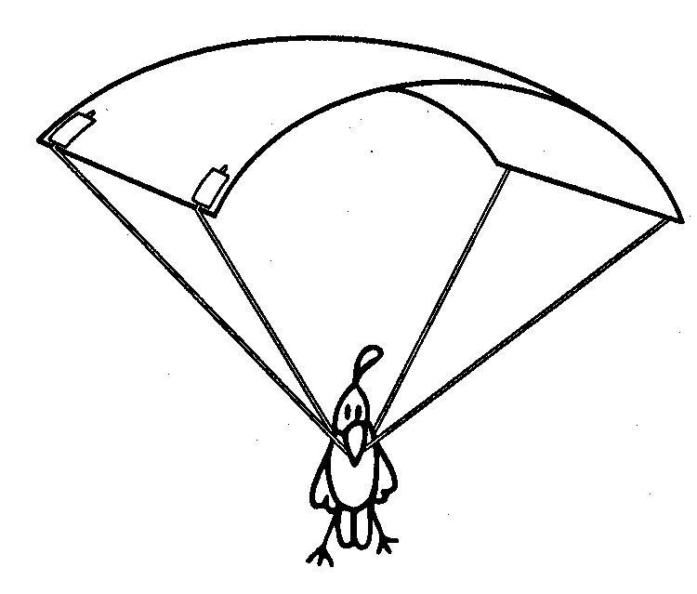
Materials:
- Paper
- Plastic wrap
- Lightweight
- String
- Tape
- Ruler
- Scissors
- Small weight (e.g. box containing a couple of marbles, unbreakable toy)

Doing it:

- Drop a small weight from a high place (e.g. drop it while standing on a chair, or from the top of a stairwell). How quickly does the object fall?

- Crumple a sheet of paper into a ball. Cut four pieces of sting of equal length. Tape one end of the pieces of sting to the paper ball. Tape the other end of the pieces of sting to the small object. Drop the object from the same height that you dropped it before. How quickly does it fall? Does this design of parachute work? Why or why not?

- Cut four pieces of sting of equal length. Make a simple parachute by taping one end of a piece of sting to each of the four corners of a sheet of paper. Tape the other end of the strings to the object. Drop the object. How well does your parachute drift to the ground? Why does the parachute make the object fall more slowly?

- Experiment with different lengths of string. What length of sting makes the best parachute? Why?

- Use different materials for the canopy. Does paper, plastic, or cloth work best? Why?

- Try different shapes and sizes for the canopy. Does a larger canopy work better than a smaller one? Why? Does a round or square canopy work better?

Science Is…
Page 472
Susan V. Bosak, Canada, Ltd. © 1991
COPTER

Materials:
- Strips of paper 6 cm x 28 cm;
- Scissors; paper clips

Doing it:
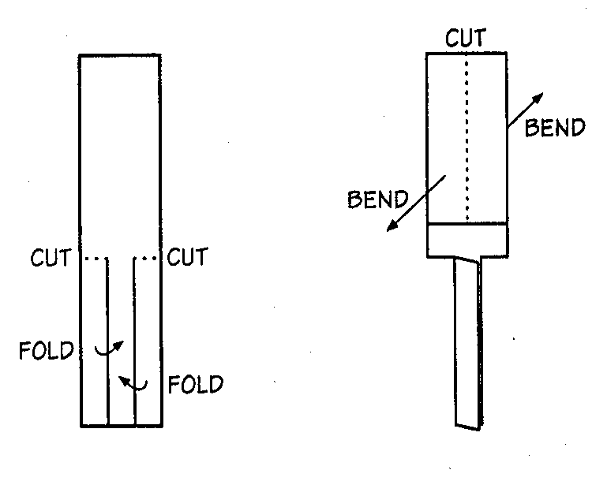
- Make a “helicopter” by cutting, folding, and bending a slip of paper as follows:

- Fold up a bit of the helicopter’s leg. Hold the fold in place with a paper clip.
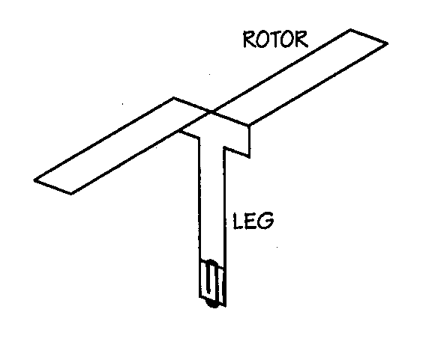

- Drop the helicopter from a high place (e.g. drop it while standing on a chair) or throw it up into the air and watch it fall. What happens? Does one end always point downward? Does the helicopter right itself if it’s dropped upside down?

- Bend the rotors in the opposite direction. How does this change the helicopter’s flight? What happens if the rotors are vertical (not folded out) when you release the helicopter?

- Add two or three more paper clips to the leg of the helicopter. Does this affect the way it falls?

- Use the patterns below to make three helicopters with different rotor areas. Which falls faster? The slowest?
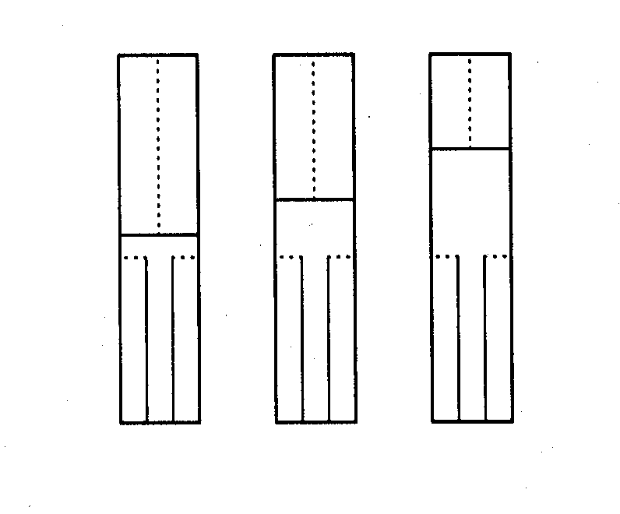

Science Is…
Page 475
Susan V. Bosak
Canada, Ltd. © 1991
THESE THINGS FLY!

Overview: These flying oddities aren’t your typical paper airplane. They may be strange to look at, but they’re simple to make and fun to fly.
Materials:
- Paper
- Paper or foam cups
- Tape
- Straw
- Elastic bands

Doing it:

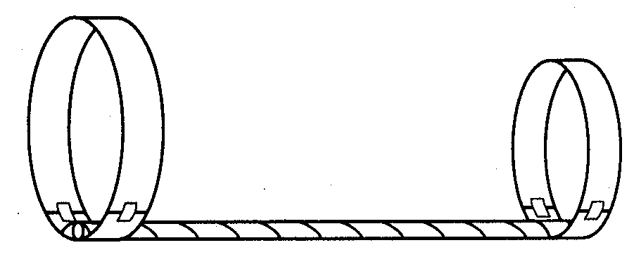
- Straw Flyer: Cut a paper strip 2 cm x 24 cm and another 1.5 cm x 18 cm. Make the strips into loops by overlapping the ends a couple of centimeters and taping the ends together on the inside and the outside. The overlapping ends should form a sleeve into which you can slip a straw. You may want to keep the straw in place with a bit of tape. What happens when you throw the Straw Flyer like a spear? Is there a difference if the big loop is in front or if the small loop is in front? How does the Straw Flyer’s flight compare to that of a plain straw? Try putting the loops in different positions along the straw. Try making the Straw Flyers with two big loops, and then with two small loops. Combine a really big loop with a really small loop. Use more than two loops. Put loops on the top and the bottom of the straw.

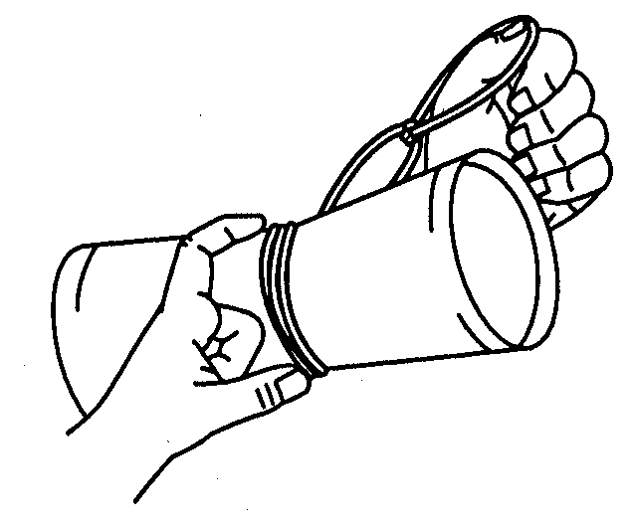
- Aero-Cups: tape together the bottoms of two paper or foam cups. Loop together the ends of five or six elastic bands to form a long chain. Wrap the elastic-band chain around the center of the two-cup structure. While making sure that the elastic band chain comes from the underside of the two-cup structure, put your thumb through the end elastic in the chain and stretch out the chain while holding the cups. Release the Aero-Cups and watch them spin through the air. Can you design a similar flying structure using four cups?

Science Is…
Page 476
Susan V. Bosak
Canada, Ltd. © 1991

THE PLANE TRUTH

Overview: By making and flying paper airplanes, you can discover some of the basic principles of aerodynamics. Here’s one of the simplest paper airplane designs, the Dart.

Materials:
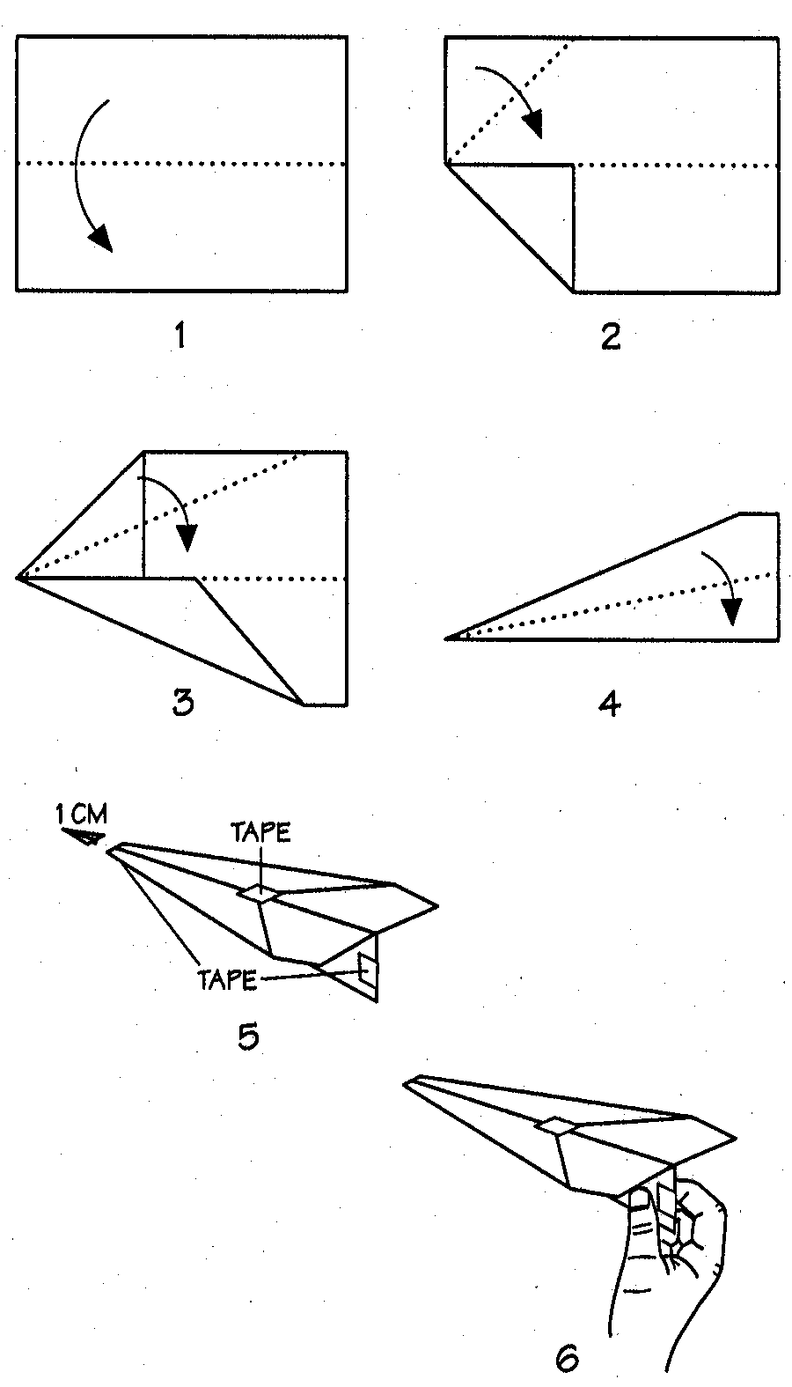
- Paper (preferably stiff paper)
- Tape
- Optional—scissors

Doing it:

- Fold a sheet of paper lengthwise, exactly down the middle. Unfold it and smooth the paper flat.

- Fold one of the corners over as far as the center fold. Then fold the other corner over in the same way.

- Fold the corners over again so that they meet at the centerfold.

- Fold the two sides together along the center fold. Then, to make wings, fold the top portion of each side down toward the center fold.

- Use a small piece of tape to fasten the wings together. If you wish, you can sip off about 1cm of the plane’s nose. Tape together the keel. (Paper under the wings) at both ends.

- Launch the Dart by holding it at the back of the keel and throwing. How long does the Dart stay in the air? How far can you throw it?

Science Is…
Page 477
Susan V. Bosak
Canada, Ltd. © 1991

PLANE DESIGN AND FLYING TIPS

These design and flying tips apply to almost any kind of paper airplane. Start with simple planes, and then try more complicated planes.

Materials:
- Paper airplanes
- Tape
- Scissors
- Paper clips-
- Different weights of paper (e.g. tracing paper, construction paper, writing paper)

Doing it:
- Space: Paper planes fly best in a large empty area where there’s a little or no wind.

- Construction: If a paper plane doesn’t fly straight, it may be because it isn’t made straight. Every little bend, cut, and dent in the paper changes how a plane flies. All folds should be sharp. Look down along the nose of a paper plane to see if both wings are the same size and bent to the same angle. Check that all the folds and cuts on one side are the same size and bent to the same angle. Check that all the folds and cuts on one side are the same size and shape as those on the other side. If your plane is lopsided, it will never fly straight. If everything looks okay, and the plane still doesn’t fly right, experiment with the factors listed below.

- Launching Speed: There’s no such thing as the “best” launching speed for paper planes. Different planes need different launching speeds. In general, try to launch a plane so that it glides in a straight path without diving, climbing, or turning. If a plane is launched too quickly, it tends to climb, then stall, and finally dive down. If a plane is launched too slowly, it dives to pick up more speed. Either way, distance and flying time are lost.

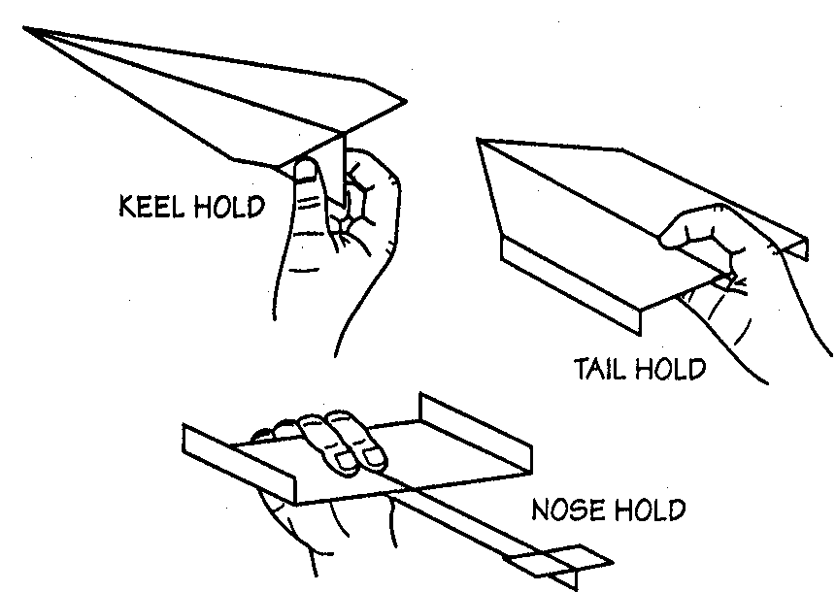
- Throws: There are many ways to throw paper planes. Different planes work better with certain throws. For the keel hold, hold the back of the plane at the bottom, and then launch the plane with a sharp throw. In the tail hold put your index finger on top of the plane with your thumb and other fingers underneath. Move your hand forward at the speed you think the plane will fly and just let the plane go. Don’t jerk or push the plane forward; just let it glide from your hand.

PLANE DESIGN AND FLYING TIPS (cont’d)
The nose hold is best for loops and circles. If you want a plane to veer to the left
or right, launch it at an angle.

- Circles: A Dart usually won’t do circles, but the Barnaby (described later) and other planes with long wingspan are good at circles. Hold a plane by its nose at you waist. Keep the bottom of the plane toward you body; the wings should be straight up and down. Pull your hand straight across from one side to the other and then let the plane go. The plane should circle and return to you. If a plane won’t do circles, be sure it isn’t lopsided and try throwing it harder.

- Loops: When you’re trying to make a plane loop, curl up the back edge of the tail or wings. For a downward loop, start by holding the plane’s nose. Aim the nose down and quickly launch the plane with a hard throw. Be careful to launch the plane straight, without twisting your wrist or curving you arm. The plane should make a look and then fly level. For an upward loop, hold the plane by its nose again. Aim the nose up. Pull the plane straight up, and let go when the plane is in front of your face. With practice, the plane should loop away from you and come back so that you can catch it.
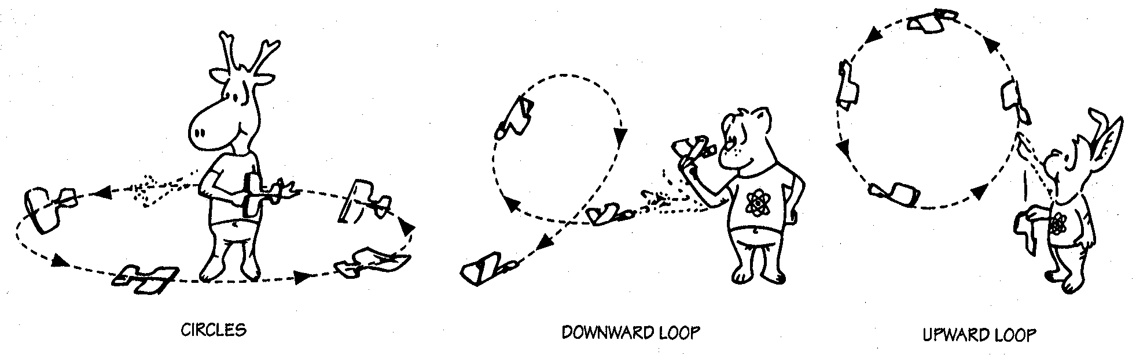
- Weight: Try making several planes using the same design, but different kinds of paper (e.g. tracing paper, construction paper, writing paper). Do the planes fly differently? In what ways? Not only is overall weight important, but so is the way the weight is distributed. Shifting weight can be used to overcome problems like interference from air currents outdoors. Add a paper clip to a plane’s nose. How does it fly? What happens is you put a paper clip on the tail instead of the nose? What happens if you add two or more paper clips? How can you tell too much weight has been added?

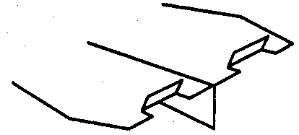
- Ailerons: Make flaps, or ailerons, for a plane by cutting two 1 cm slits in the back of each wing. Bend the flaps. What happens when both flap are tilted up? What happens when both flaps are tilted down? What happens if only one of the flaps is bent out? Try tilting one flap up and the other flap down. Try different flap widths.
PLANE DESIGN AND FLYING TIPS (cont’d)

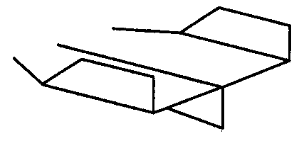
- Vertical Stabilizers: These are used to make a plane fly straight and smooth. Bend the tips of the wings upward. What happens if you have only one stabilizer on a plane instead of two? Try bending the stabilizers down instead of up. Try making small stabilizers, and then try larger stabilizers.

- Rudders: Flaps in vertical stabilizers can be used as rudders that change the
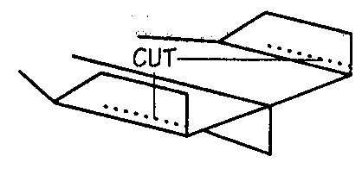
direction of a plane’s flight. Turn both rudders
slightly l the same way, to see one change in flight.
Then turn them the other way. Try bending in just
one rudder. Try bending both rudders outward.

- Cambering: Curve a paper plane’s wings downward slightly by running them
between you thumbnail and fingers. This will create a slight arch in the wings
and the plane may fly better.

- Extension: Come up with your own paper airplane design. Then write
instructions, including diagrams, for making the plane. Can someone else follow
your instructions and make the plane?

Science Is…
Page 479
Susan V. Bosak
Canada, Ltd. © 1991
STUNT FLYER

Overview:
Once you’re familiar with making and flying paper airplanes, the Stunt Flyer is an interesting, simple plane to try.
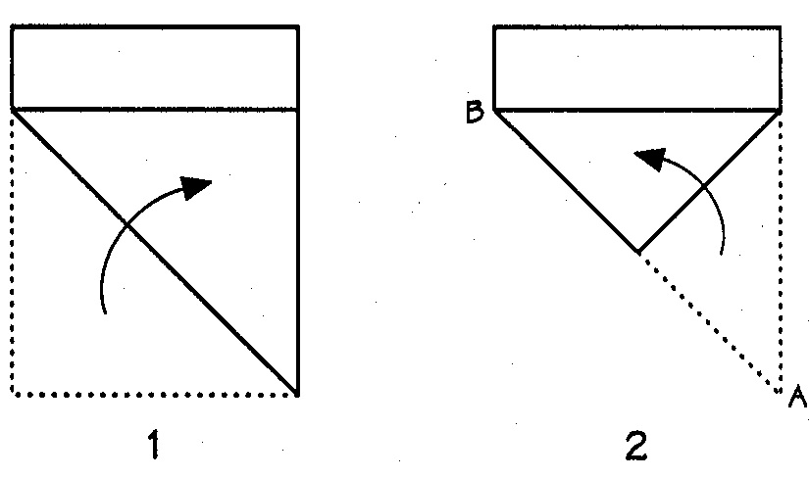
Materials:
- Paper (preferably stiff paper)
- Tape

Doing it:
- Fold up one corner of a sheet of paper to the opposite side.
- Fold over point A so that it meets point B.
- Fold up the bottom tip to the centre.
- Fold the paper in half.
- Fold down each wing so that the crease is approximately 2 cm from the bottom of the plane (i.e. keel is 2 cm).
- Fold up each wing tip by 1 cm.
- Use a small piece of tape to fasten the wings together. Also, tape together the keel at both ends. You’re ready to launch.

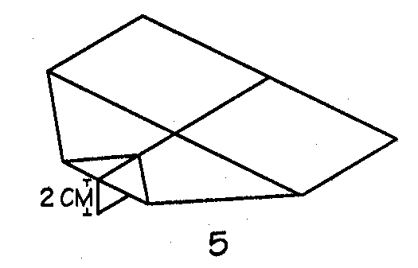
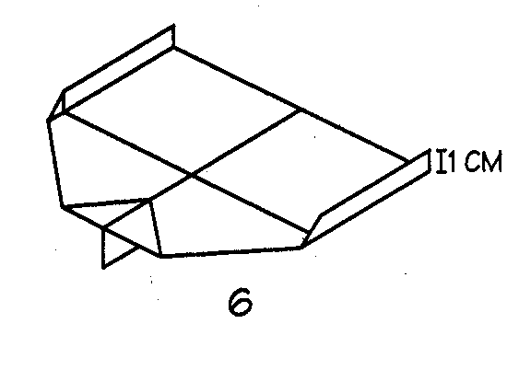

Science Is…
Page 480
Susan V. Bosak
Canada, Ltd. © 1991
BLUNT NOSE

Overview:
What happens when a plane has a blunt, rather than a pointed, nose? Make this plane and see what it can do.

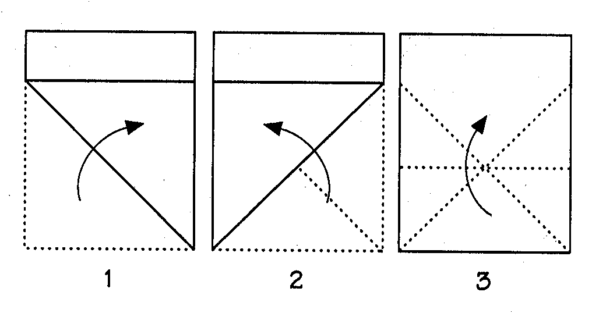
Materials:
- Paper

Doing it:
- Fold up one cover of a sheet of paper to the opposite side. Unfold the paper.
- Fold up the other cover of the paper. Unfold it.
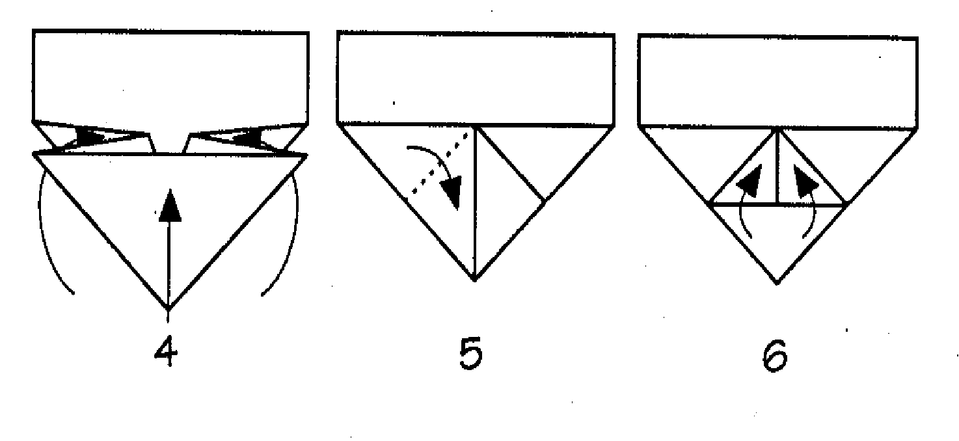
- Fold up the bottom edge of the paper so that the crease goes through the spot where the first two creases cross. Unfold the paper.
- Fold the paper along the crease like an accordion.
- Fold down both corners of the pleat toward the centre tip.
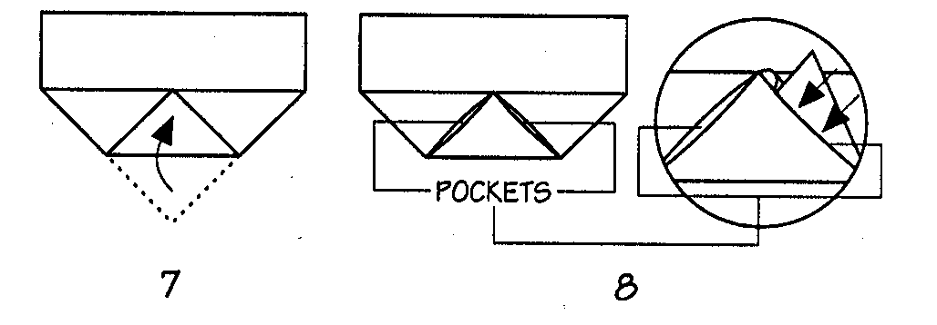
- Fold up the two bottom points of the first layer of paper.
- Fold up the bottom tip of the second layer of paper so that it covers the other points.
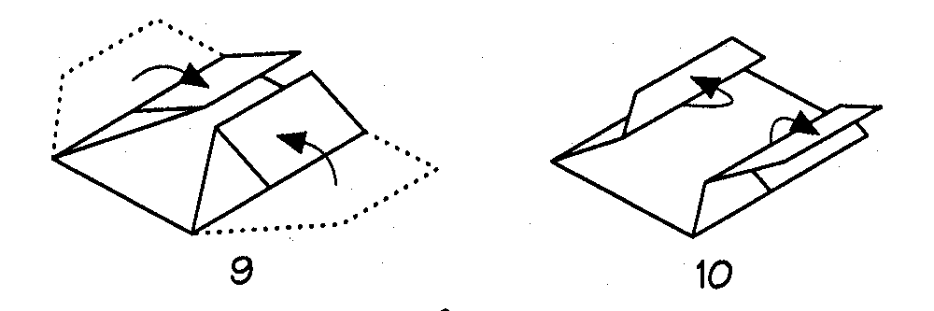
- Now comes the tricky part. Look for the two pockets. Underneath these pockets are two, triangular flaps. Tuck these flaps into the pockets to hold them securely in place.
- Turn the paper over. Fold both wing tips toward the center.
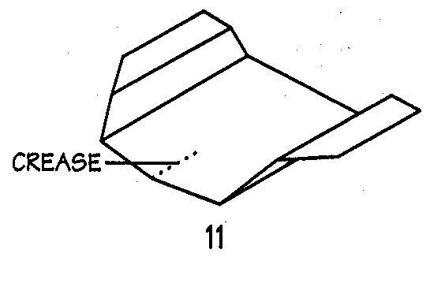
- Fold out the edge of each wing.
- Crease the center, front of the plane to give it a gentle, upward curve. You’re ready to launch.

Science Is…
Page 481
Susan V. Bosak
Canada, Ltd. © 1991
THE BARNABY
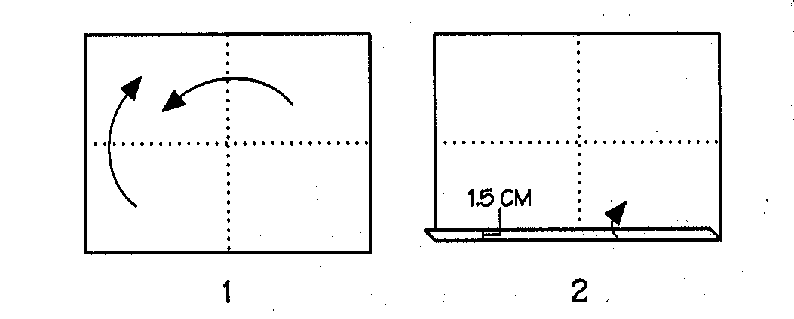
Overview: The Barnaby was designed by Ralph S. Barnaby, who was a captain in the United States Navy. Make this plane and follow in his footsteps.

Materials:
- Paper (preferably stiff paper)
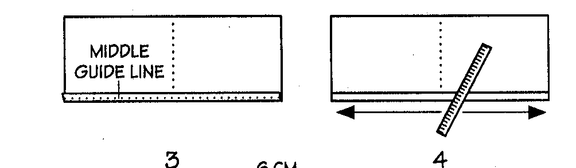
- Ruler
- Pencil
- Scissors

Doing it:
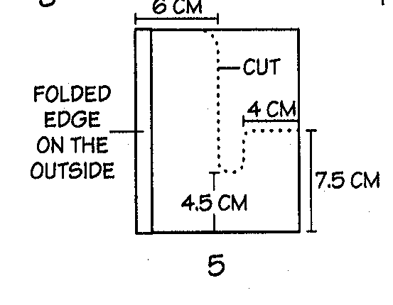
- Fold a sheet of paper exactly down the middle. Unfold it. Fold the paper exactly down the middle in the other direction. Unfold it. The creases are your guidelines.

- Make a 1.5 cm fold along the long edge.
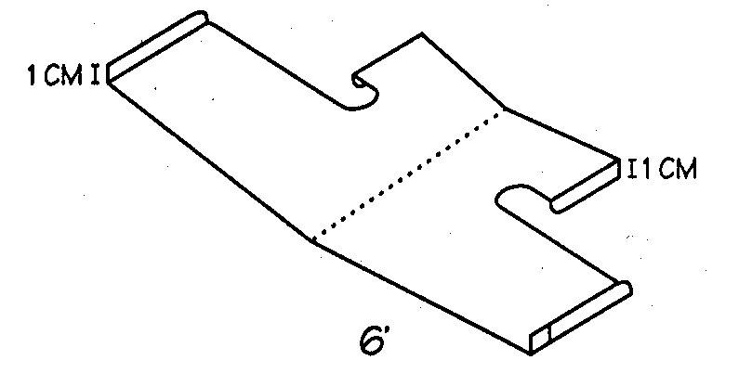
- Fold the folded edge over and over until you meet the middle guideline.

- The last fold has to be very tight; so press your ruler down hard on the paper and run it along the edge.

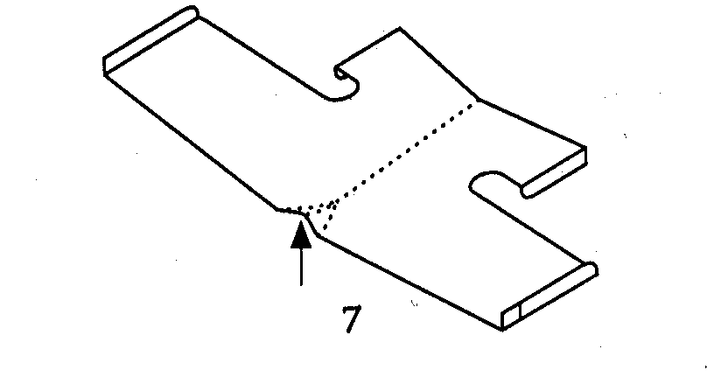
- Fold the paper in half (folded edge on the outside). Draw and cut out the shape shown.

- Open the plane. Fold up 1 cm of each wing tip. Fold down 1 cm on each side of the tail.

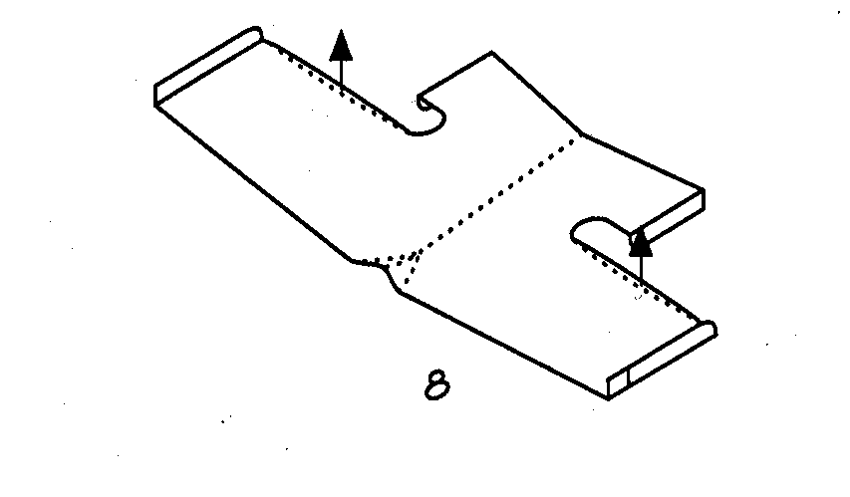
- Bend up a small portion of the folded-over edge, near the center. This will stiffen the wings and hold them in place.

- Bend up the back edges of the wings a bit. You’re ready to launch.

Science Is…
Page 482
Susan V. Bosak
Canada, Ltd. © 1991
AIR SCORPION

Overview: If you like planes that fly fast, this design is for you. After a little folding and cutting, it looks very much like a get plane.

Materials:

- Stiff paper
- Tape
- Ruler
- Pencil
- Scissors
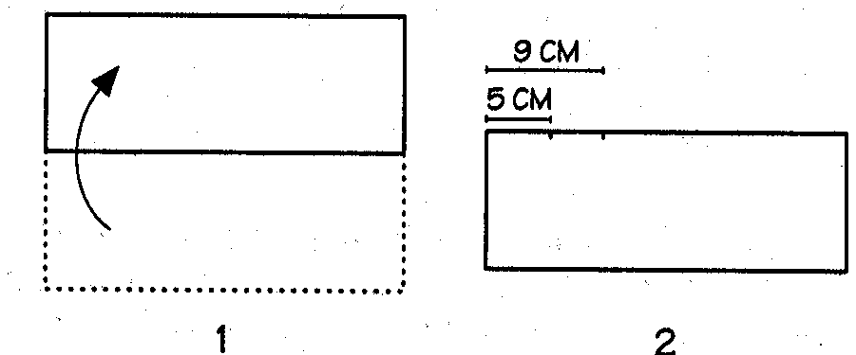
Doing it:
- Fold a sheet of paper lengthwise, exactly down the middle.

- Mark lines along the top edge of both sides of the folded paper. Mark one line 5 cm from the end and the other line 9 cm from the end.
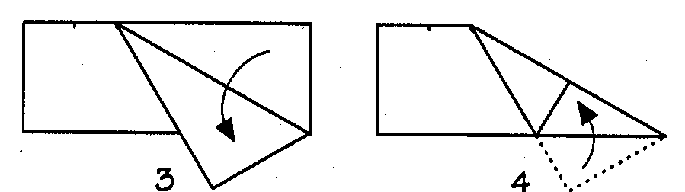
- Fold down the far cover to the 9 cm mark. Fold the corner on the other side of the paper in the same way.

- Fold the overhanging tips up
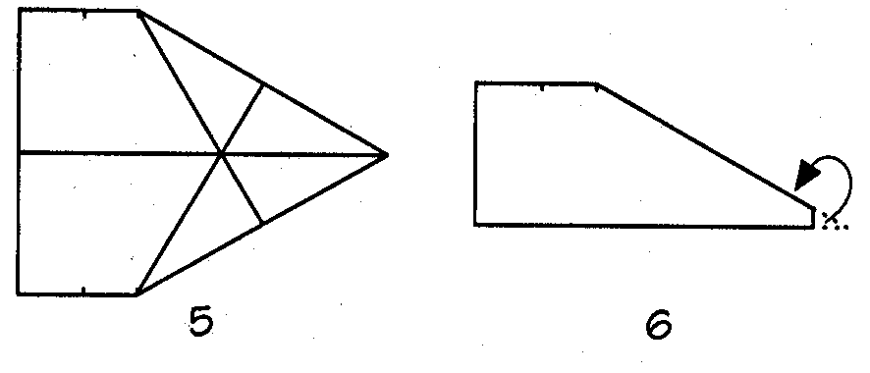
- Open the two halves of the paper. It should look like the illustration.

- Close the two halves again. Fold the nose back and between the halves.

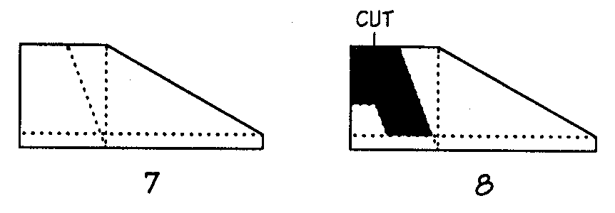
- Draw three lines: the first one vertically from the 9 cm mark to the bottom of the fold; another across the bottom of the fold, 1.5 cm up from the fold; and one diagonally from the 5 cm mark.

- Draw in a tail at the back of the plane. Cut out the shaded area shown.

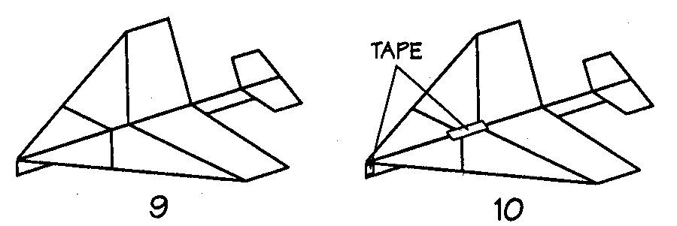
- Bend the tail and wings along the line which is 1.5 cm from the fold (i.e. line drawn in step 7).

- Keep the wings in place with tape. Tape the nose.

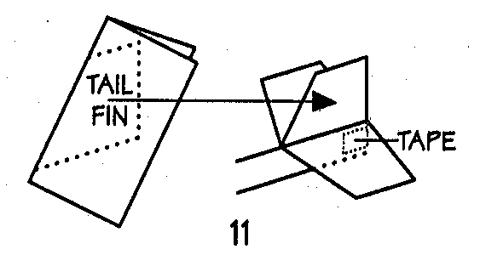
- Draw the tail fin pattern on a folded piece of paper. Cut it out. Tape it to the inside of the back end of the plane. You’re ready to launch.

Science Is…
Page 483
Susan V. Bosak
Canada, Ltd. © 1991
SUPER ZOOMER

Overview: This paper airplane involves more construction work that other paper planes, but it’s a great flyer and an interesting design.
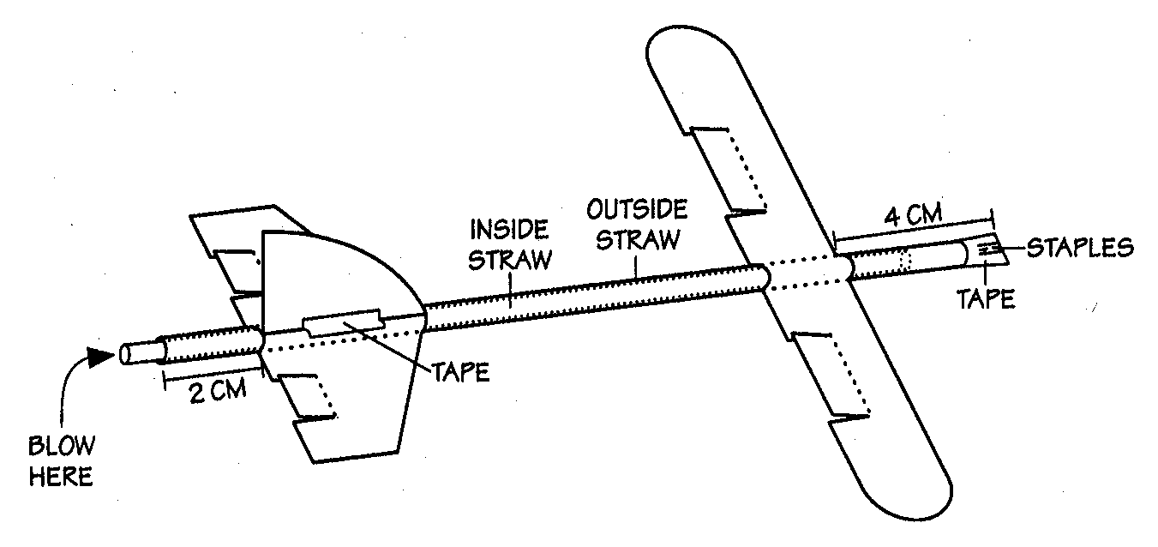
Materials:
- Thin drinking straw
- Fat drinking straw (wide enough so that thin straw fits inside)

- Stapler
- Tape
- Stiff paper
- Ruler
- Pencil
- Scissors
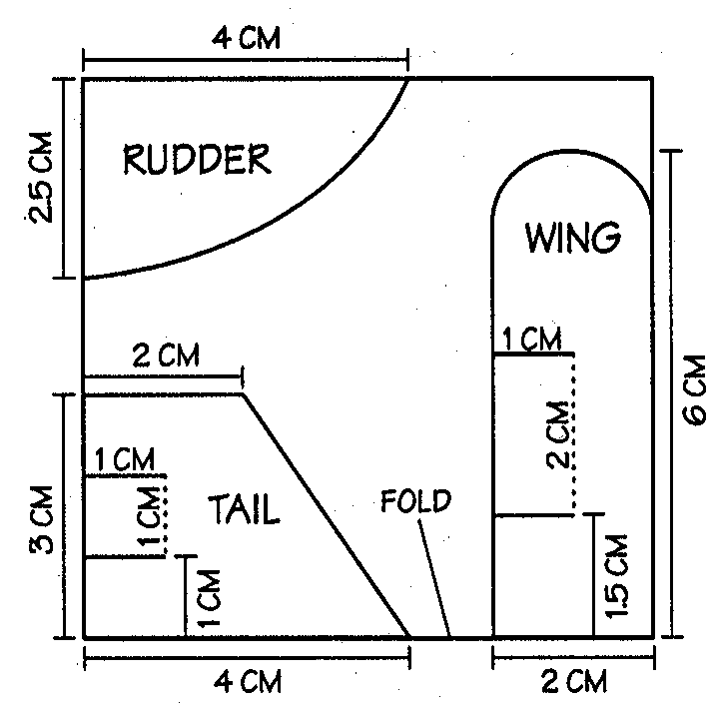
Doing it:
- Staple one end of a fat straw several times. Seal the end with tape to make it airtight

- Fold a sheet of paper in half. Draw the plane parts on the folded paper, as shown.

- Leaving the paper folded, cut out the wing and tail.

- Make the rudder out of only one thickness of paper.

- Make the wing and tail flaps by cutting the four solid lines (in illustration). Bend each flap up slightly

- Open the wings and tape them to the fat straw, 4 cm from its closed end.

- Open the tail and tape it to the fat straw, 2cm from the open end.

- Tape the rudder to the top of the tail.

- To fly the plane, put the thing straw inside the fat straw. Bend your head back a little. Holding onto the thing straw, blow into it. The plane should shoot into the air.

- Experiment with the Super Zoomer, using the design and flying tops discussed earlier.

Science Is…
Page 484
Susan V. Bosak, Canada, Ltd. © 1991

ADDITIONAL ACTIVITIES

MACARONI MECHANICS

Type of Competition: Individual or team
Composition of team: 1-2 Students

Purpose: To gain hands-on experience in project planning and completion
using the principles of motion.

Student Objective: To design and build a car from different shapes and sixes of pasta
that is fast, travels far, and demonstrates creativity of design.

Judging Objective: To select the winners in each of three areas; speed, distance, and
creativity in design.

Materials:
Construction:
- Various types of pasta
- Any glue except super glue
Judging:

- Ramp (provided by teacher)
- Scale
- Timer
- Measure tape
- Competition Summary

Rules for Construction:
- Only the materials listed above are allowed. No substitutions.
- Only cars completely constructed PRIOR to the competition should be allowed to compete in the competition.

Rules for Judging:
- At race time, car will be placed on ramp with its back wheels on start line. One team member will release the car. Car will be clocked for speed form start line to finish line. (2 feet from base of ramp).
- Car will be allowed to roll to a full stop, where distance will be measured.
- Car may not be touched while race is in progress.

Judging:
- Cars will be rated in categories of speed, distance traveled, and design creativity.
- In case of a tie, the lightest car wins.

CAPITOL CENTER
ELEMENTARY MESA DAY
WRITE IT DO IT

Description: The event will test a competitor’s ability to communicate with a colleague in writing.

Type of Competition: Team
Composition of Team: 2
Time: 55 minutes

The competition:

- A student is shown an object, a system, or an arrangement built from blocks, science equipment, science materials, Tinker Toys, Legos, Contrux, Lincoln Logs. Straws and pipe cleaners or other inexpensive materials. Students may be sharing models.

- The student has twenty-five (25) minutes to write a description of the object and how to make it. There will be no advantage to finish early. Only words and numerals may be used. Symbols and diagrams are not allowed. All abbreviations must be defined either at the beginning or when the abbreviation is first used.

- The supervisor of the even will pass the description to the remaining team member (in another room) who will take the description and attempt to recreate (build) the original object in twenty (20) minutes.

Scoring:

The team, which builds the object nearest to the original, is declared the winner. A point will be given for each piece of material placed in the proper connection. No penalty will be assessed for parts that were not assembled. Use of diagrams or pictures will disqualify the team. The decision of the judges is final. The teacher will need to judge or assign judges. Time for the construction phase only may be used as a tiebreaker. The group with the least amount of time will be designated the winner.

Science Olympiad
2001

BAGGIE SCIENCE

Type of Activity: Team
Composition of Team: 4 students per team

OVERVIEW: This activity introduces students to the idea of chemical reactions. As student teams work together the excitement mounts as they watch changes occur when the chemicals inside their zip-lock bag are mixed. The bag gets hot, inflates with gas, the bubbling contents change color and the liquid turns cold, all within a matter of minutes. The task then becomes one of designing and conducting a series of experiments to determine which variables produce the different reactions.

PURPOSE: This activity teaches students to observe, experiment, and make inferences.

OBJECTIVES: Students will be able to: Observe changes and design experiments to explain observations.

Materials (See Science Teacher at your school):
Calcium chloride - CaCl₂ (road salt)
Sodium Bicarbonate - NaHCO₃ (baking soda).
Bromothymol Blue
plastic zip-lock bags
graduated cylinders
plastic film canisters

ACTIVITIES: Tell students they will be doing an activity involving a chemical reaction and then designing some experiments of their own. For the first part of the activity they will need to observe very carefully. Give teams of students 5-10 minutes to use all their senses EXCEPT TASTING to write down observations such as "looks like small styrofoam moth balls" or "has a strong odor". Write down observations on the right side of the worksheet.

Demonstrate procedure outlined on Chemical Reactions sheet, but don't spill the bromothymol blue. Discuss leveling off teaspoon to get consistent measurement. Tell students the reactions will happen quickly so they will have to concentrate and watch closely.

Students should write down the reactions.

WARNING!! Excitement is high! Students are amazed at the reaction. They will want to repeat the experiment 3-4 times to validate the sequence of reactions. At the end of class period gather students back together and list reactions on the board.
BAGGIE SCIENCE (cont’d)
Reactions should include:

turns blue
turns green
turns yellow
gets cold
gets hot
forms gas

During this session students will design and test experiments to determine which variables caused the different reactions. Summarize the results from the last session. Ask students what they think caused the fizz and bubbles? What caused it to get hot? What caused the gas to form? Note that three things went into the baggie, two dry chemicals and one fluid. Ask them how they could design experiments to test the variables. List ideas and discuss.

Select one of the students' ideas and show them how to write it down. For example, "If you mix everything but the baking soda, it will get hot."

CaCl₂ + bromo blue -> hot

Challenge students to design experiments by combining 2 variables and recording results. Which reactions are dependent on the combinations of all 3 variables? Gather the class together at the end of the session to go over the results.

RESOURCES: The following quantities are enough to conduct each activity 2-3 times with a group of 30 students.

1. 1.5 lbs. sodium bicarbonate (baking soda).

2. 3 lbs. calcium chloride - purchase at chemical supply house, at some hardware
stores (ask for "road salt"), or borrow from local high school.

3. Bromothymol blue - concentrate to make 1 gallon.

- 5-6 plastic zip-lock bags per student team.

- 5-6 plastic vials per team - go to the photo store and ask for the clear plastic
35 mm film containers.

BAGGIE SCIENCE (cont’d)
For each team set up a tray with:

1. Calcium chloride - CaCl₂
2. Sodium Bicarbonate - NaHCO₃
3. Bromothymol Blue
4. 10 ml graduated cylinder

TYING IT ALL TOGETHER:
Adapted from Chemical Reactions, GEMS,; Lawrence Hall of Science, U of Calif., Berkeley, CA and article "The Baggie Problems", Scott Bowler, Catlin Gabel School, Portland, OR.

Academy Curricular Exchange
Columbia Education Center
Science

http://www.ofcn.org/cyber.serv/academy/ace/sci/elem.html

Judith Holt-Mohar, Odell Elementary
Hood River, OR

PINHOLE CAMERA

Type of Activity: Team

Composition of Team: 2 – 4 students team

OVERVIEW: Imagine reaching for something that is visible in front of you and not finding it there, or shining a flashlight in the darkness and having it illuminate only something in back of you. This, of course, is not likely to happen, since light travels in
straight lines. It is true that a beam of light can "bend" under certain conditions, such as when going from air into water or glass, and the reverse. Scientists now know that light passing through space is attracted and curved by the gravitational fields
of massive objects in space. Other than these exceptions, though, light does appear to travel in straight lines. This property makes many interesting things take place.

The pinhole camera demonstrates this property in an interesting way. Light shines through a narrow pinhole in the cereal box end. At the other end, an inverted image appears on wax paper taped over the opening. Why? If light travels in straight lines, the light going from spot one on the left can only go to spot one on the right, and so on.

PURPOSE: The purpose of this activity is to introduce students to a basic property of light and how we use this property in our everyday lives.

OBJECTIVES: Students will be able to understand how the image is inverted--because light travels in straight lines.

ACTIVITIES:

1. Punch a hole in the center of the box using the pin.

2. Remove the box top. Put wax paper over the box's open end to make the screen.
Use a rubber band to hold it.

3. Point the camera at brightly lit objects in or outside a darkroom. What do you see
on the wax paper screen?

The observer's eyes will need to be about 30 centimeters away from the screen to see and sharp image. To use the camera in a lighted place, you must shield it the screen from light. Roll black paper into a large tube and fit it around the screen end of the box. Press your face against the paper shield's open end to images on the screen.

PINHOLE CAMERA (cont’d)

Other Activities:

1. How must you move the camera to do these things?

a. To make the image move right? Left? Up? Down?
b. To make the image get smaller? Larger?

c. What happens if the camera is still and the image moves?

2. How can you make a brighter, sharper image appear on the screen? What would
happen to the image if you:
a. Change the pinhole size?
b. Line the inside of the box with black paper? White paper?
c. Use a longer or larger box or a shoebox?
d. Use paper other than wax paper for the screen?

RESOURCES/MATERIALS NEEDED:

Salt or oatmeal box Rubber band
Sticky tape Wax paper
Pin Scissors
Black paper

Your local library is an excellent resource for more information on light and its properties.

TYING IT ALL TOGETHER: Make the drawing illustrated on the front page on the chalkboard, except leave out the arrows. See if the students can draw the arrows in. If they cannot, draw the arrows in for them and let the students explain what happens.

If you wish to extend this activity further, invite a professional photographer to bring his camera and talk about how the images the camera receives are recorded on film.

Academy Curricular Exchange
Columbia Education Center
Science

http://www.ofcn.org/cyber.serv/academy/ace/sci/elem.html

Patricia Willett, Designs For Learning Differences
Albuquerque, NM

TOOTHPICK BRIDGE COMPETITION

Objective: Design and build a bridge using toothpicks and glue. The bridge will be judged on strength and lightness of the structure.

Team size: 1- 3 persons per bridge. Each student can only be associated with one bridge

Rules:
- The bridge MUST span a gap of 40 cm, resting on supports 30 cm high by 3 cm thing. In general, bridges should be between 42 and 47 cm long. (See figure 1)

- The bridge can only rest ON THE TOP surface of the supports and against the INSIDE of the vertical supports for no more than 5 cm from the top.
(See figure 1)

- The bridge must be AT LEAST 5 cm WIDE throughout its entire length, and MUST PROVIDE a 5 cm x 5 cm flat surface at the top center for use as a loading platform. (See figure 1)

- The official toothpicks are FLAT toothpicks. The official flue is Elmer’s brand WHITE glue. The use of any other materials other than the official construction materials will be grounds for disqualifying a bridge.

- Toothpicks may be shortened, blunted or bent.

- Glue may only be applied to joint and splices. Toothpicks placed alongside each other cannot be bonded together over their entire length. (See figure 2) The general rule for applying glue is “Use a dot of glue, not a line of glue”

- Bridges may not be painted

- Bridges must weigh less than 1.0 lb or 0.45 kg.

- Bridges must be completely assembled when submitted for testing.
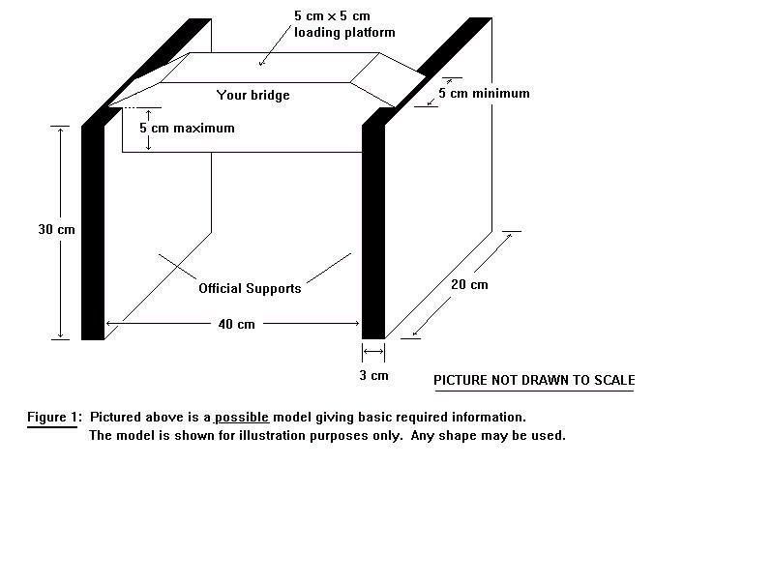
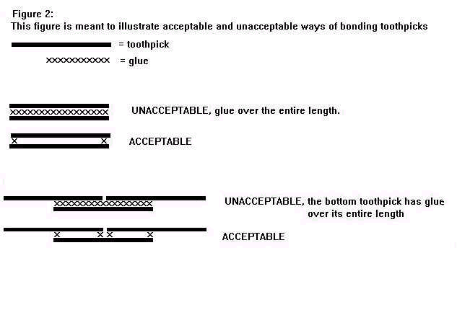

Toothpick bridge (continued)

Judging:
- Bridges must confirm to all rules and must hold at least 1.5 kg or 3.3 lbs to win.
- Bridges supporting the minimum weight of 1.5 kg will be ranked according to their self weight. The lightest bridge will receive 50 bonus points, the second lightest 30 bonus points and third lightest 10 bonus points.
- Bridges will be loaded until the point of failure or breaking. Bridges will receive points for their strength.

Points = Failure load ___
Weight of the Bridge

Total score = Failure load __ + Bonus Points
Weight of the Bridge

- First, second and third place prices will be awarded to the top (highest) three scores.
- The winning bridge is the most efficient bridge, not necessarily the strongest bridge.

Technology Discovery Day 2000
Student Chapter of the American Society of Civil Engineers
September 25, 2002
Http://eng-sci.udmercy.edu/precol/techday/comp_rules.htm

Tetrahedral Kites

Type of competition: Team
Composition of team: 2 students

Judge’s Scoring Rules:

Style Integrity
Does every tetrahedron have six straws? Yes No
Does every tetrahedron have two covered sides? Yes No
Is the covering material unusual or attractive? Yes No
Was there an effort to neat? Yes No
Are any parts of the kite colorful or decorative? Yes No
Total Points Possible (30pts) Total Points Earned _________

Structural Integrity
Are connections sturdy?
Are coverings secure and the right size for the frame?
Are the straws rigid, e.g. neither curved nor bent?
Total Points Possible (30pts) Total Points Earned _________

Flight Integrity
Tie string to a corner so that the two covered sides are against the wind. Students run into the wind to launch the kite.
Do students successfully launch the kite?
Do kites fly a minimum of five minutes?
Once landed, are kites still intact?
Total Points Possible (40pts) Total Points Earned _________

Winner will have the most points.

Tetrahedral Kites

Type of competition: Team
Composition of team: 2 students

Materials:
- Transparent jumbo straws (60/3) level kite- 6/tetrahedrons).
- 60 inch/pyramid cable cord string or any string that is thing enough to thread through straws twice and will not unravel too easily.
- Glue
- Tissue paper in a variety of colors.
- Several patterns for cutting the tissue paper.
- Scissors
- Tape measures or yard sticks

Steps for Building tetrahedral kites:

Start by building the 10 individual pyramids

Step 1: Cut string to be 60 inches in length

Step 2: Thread all but 2” of string through 3 straws (A, B, C). You should have
34” of string left over.

Step 3: Form the three straws into a triangle and tie off. Make sure the string
is taut.

Step 4: String two more straws on the long end of the string. Use those two
straws to form a triangle using straw A or straw C as one of the side of the new triangle. Again, tie off making sure string is taut. You should now have a rhombus (parallelogram) composed of two equilateral triangles.

Step 5: There are two options for this step:
      - Re-thread the long string through straw A or B (it must be one of
the straws next to the know just made) and pull it all the way through, taut. HINT: If students have trouble rethreading the string. It’s helpful to tilt the straw up and inhale: putting gravity to work!!!

      - Cut the long string about a half-inch from the knot. Securely knot one end of the cut string in between straws B and C. (This is a good option if you find that your string is too flimsy or unravels easily).

Step 6: Thread 1 new straw (F) onto the remaining string.

Step 7: Rotate the straw to create a three dimensional triangle (tetrahedron)
connecting the straw where D, E, and F come together (here you will
tie the final knot).

Step 8: Repeat steps 1-7 to make 10 individual tetrahedrons.

Step 9: Trace cardboard shape onto the tissue and cut out tissue. (Each
tetrahedron will need 2 piece of tissue – for aesthetic purposes, we
suggest that students use only one color per tetrahedron).

Step 10: Use the combination of glue and water to glue each tissue onto
different, but adjacent sides of the pyramid.

To attach:
- Place pyramid on top of a cut out piece of tissue flat on a
table. We suggest putting newspaper down under the project.

- Brush glue onto the tissue lying outside the triangle being covered.

- Fold the portion with flue over the straw.

Step 11: The pyramid together at the corner in a three-tiered pyramid
formation, making sure that the tissue covered sides all face in the
same direction so that the kite can catch the wind. *Note: The bottom
layer will have 6 pyramids, the middle 3, and the top 1.

Tetrahedron Kite

Competition Summary

# | Name #1 | Name#2 | Style Integrity (30) | Structure  Integrity (30) | Flight Integrity (40) | Total
1
2
3
4
5
6
7
8
9
10
11
12
13
14
15
16
17
18

CAPITOL CENTER
ELEMENTARY MESA DAY

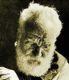
TETRAHEDRAL KITE HISTORY

Bell Tetrahedral Kite

What is it? Who invented it?

History of the Tetrahedral Kite

At the start of the century, leading scientists were working to prove that large full-sized flying machines were just impossible. Their proof was that to increase a kite (or flying machine) to give it twice the surface area, you would have to increase its weight by 4 times!

Alexander Graham Bell looking at this situation after his huge success with the telephone decided to get involved. In 1902 he wrote the proof that it was indeed possible to build large flying machines without the increasing weight cost. Instead of building one large wing, his proof was based on a whole `flock' of small wings in the form of “tetrahedrons”.

You can find out more about Alexander Graham Bell from the
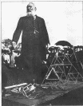
Alexander Graham Bell Institute (http://bell.uccb.ns.ca/)
Tetrahedral Principle in Kite Structure (http://home.snafu.de/thomiru/bell_eng.htm)
Online Encarta Encyclopedia (http://encarta.msn.com/find/Concise.asp?z=1&pg=2&ti=04249000)
Family Papers, Library of Congress (http://memory.loc.gov/ammem/bellhtml/bellhome.html)
Alexander Graham Bell -in German, but great photos (http://www.drachenarchiv.de/snoek1040.htm)
Some Historical Tidbits (http://enterprise.sct.gu.edu.au/~anthony/kites/tetra/bell/historical_tidbits.txt)
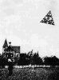
What is a Tetrahedral Kite?
Tetrahedrons are a regular 4-sided polygon. Basically a pyramid shaped framework which is the strongest structure known. A tetrahedral kite is formed when you cover two sides of the four-sided figure and to join a number of these together into a large tetrahedral kite.

Source:http://enterprise.sct.gu.edu.au/~anthony/kites/tetra/bell/
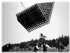
By doing this Mr. Bell was able to prove that you can create a large kite, of any size desired, without any increase in the weight to sail area. You do not need any extra bracing in larger kites and the strong tetrahedral cell is itself fully braced. In fact the more cells you add to a flying machine, the stronger it becomes. This allows you build tetrahedrals from the lightest materials but still have a strong and sturdy final product.

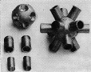
A recent scientific study, “Tetrahedral Principle Revisited'', even reversed this position, showing that the more cells a tetrahedral kite has the better the surface to weight ratio becomes due to sharing of the joints between cells.

Tetrahedrons, space filling structures

The main disadvantage is that a tetrahedral IS a space generating structure. Large box kites have a decidedly open and airy look to them. Large tetrahedral kites on the other had looks like a solid object flying in the air as each cell becomes small with respect to the complete kite.

The solidness of this structure however has become known as an ``Octet Truss'' and is now used all over the world due to its ridgedness. In fact the new “Space Station'' will be using this structure heavily.
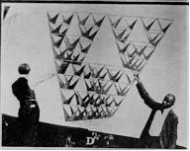But because of this `space filling' structure and the involvement of lots of individual cells, tetrahedral in general do not easily fold up for storage, or requires lots of fiddling when putting them together or disassembling. This is why you do not see very many tetrahedral kites at festivals.

The newest tetra kite plans, such as my own tetrahedral kite plan (http://enterprise.sct.gu.edu.au/~anthony/kites/tetra/plan/) or the TetraLite Construction Manual (http://www.tetralite.com), on the other hand are built from easily available modern day materials, and fold flat quickly and easily for transport. Something that I am sure Mr. Bell would have loved to have seen.

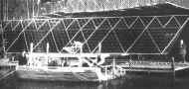
Sky’s the Limit

Mr. Bell’s ultimate achievement with tetrahedral kites was a kite built of 3,393 cells, and was named the ``Cygnet'' (see photo right). The kite was towed behind a steam ship and actually carried a passenger, a Lt Thomas E. Selfridge. After the initial flight however the kite was destroyed immediately after landing, before the steamer crew could cut the towrope.
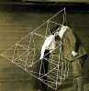

Mr. Bells Tetra Construction

All Mr. Bell’s tetrahedral cells were made separately and are were 10 inches on a side (rather small). They were made from spruce rods, and covered with bright red silk. Each cell weighed about an ounce, and were joined together by ingenious metal fittings. The townspeople of the nearby small town of Nova Scotia, Canada, were enlisted into making thousands of these tetrahedrons, and became quite a local cottage industry.

http://enterprise.sct.gu.edu.au/~anthony/kites/tetra/bell/
June 26, 2002
Created: 16 June 1996
Updated: 8 August 1997
Author: Anthony Thyssen, <anthony@cit.gu.edu.au>
WWW URL: http://anthony.kitelife.com/tetrahedral/

Tips and Techniques

TetraLite Kites
http://www.tetralite.com/tips.html
June 26, 2002
How to keep from breaking sticks during landings.
One trick (if you can call it a "trick") that I use when landing is to just set my reel down and haul in the line fast enough to bring the kite up to my hands and not let it touch the ground. When the kite is landed (here's another trick that maybe you know), I always "turn the line over" that piled up on the ground. By this I mean, starting at the kite, I take the line and start running it through my hands and re-piling it on the ground (not on top of the line that's already on the ground!), such that the line can then be spooled back on the reel from the top of this new pile, rather than from the bottom. This keeps the line from getting tangled, because the line is coming off the top of the pile instead of the bottom, which would make the line bunch up together and thereby make it tangle. I've found that knowing this makes it easier to deal with hauling kites in rapidly since you don't have to worry about tangling the line.

Bubble - Powered Rocket

The Space Place
http:// space place.jpl.nasa.gove/rocket.htm
May 13, 2002

This activity can be found on the following pages.

Build a Bubble-Powered Rocket!
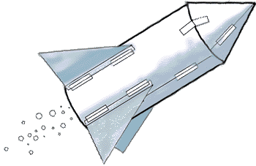
Build your own rocket using paper and fizzing tablets! Watch it lift off. How high does your rocket go? Print this page for the instructions.
Suggestion: Find a grown-up to do this activity with you.

Materials:
- Paper, regular 8-1/2- by 11-inch paper, such as computer printer paper or even notebook paper.
- Plastic 35-mm film canister (see hints below)
- Cellophane tape
- Scissors
- Effervescing (fizzing) antacid tablet (the kind used to settle an upset stomach)
- Paper towels
- Water
- Eye protection (like eye glasses, sun glasses, or safety glasses)

Hints:  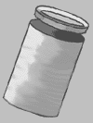 | The film canister MUST be one with a cap that fits INSIDE the rim instead of over the outside of the rim. Sometimes photography shops have extras of these and will be happy to donate some for such a worthy cause.  Keep in mind: Just like with real rockets, the less your rocket weighs and the less air resistance (drag) it has, the higher it will go.

Making the Rocket
You must first decide how to cut your paper. You may cut it the short way or the long way to make the body of the rocket. There is no one right way to make a paper rocket. Try a long, skinny rocket or a short, fat rocket. Try a sharp nosecone or a blunt nosecone. Try it with fins or without fins. Experiment!
Here's just one idea for how you might cut your whole rocket from one piece of paper:
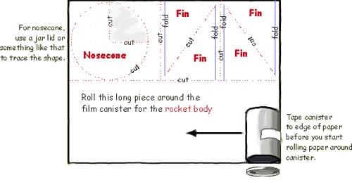
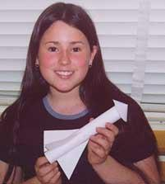
Here are the basic steps:
- Cut out all the pieces for your rocket.
- Wrap and tape a tube of paper around the film canister. Hint: Tape the canister to the end of the paper before you start wrapping.
Important! Place the lid end of the canister down.
- Tape fins to your rocket body, if you want.
- Roll the circle (with a wedge cut out) into a cone and tape it to the rocket's top.
Blasting Off
- Put on your eye protection.
- Turn the rocket upside down and remove the canister's lid.
- Fill the canister one-third full of water.
Now work quickly on the next steps!
- Drop one-half of an effervescing antacid tablet into the canister.
- Snap the lid on tight.
- Stand your rocket on a launch platform, such as your sidewalk or driveway.
- Stand back and wait. Your rocket will blast off!
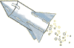

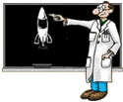
So, Dr. Marc, how does the pop-rocket work?
When the fizzy tablet is placed in water, many little bubbles of gas escape. The bubbles go up, instead of down, because they weigh less than water. When the bubbles get to the surface of the water, they break open. All that gas that has escaped from the bubbles pushes on the sides of the canister.
Now when you blow up a balloon, the air makes the balloon stretch bigger and bigger. But the little film canister doesn't stretch and all this gas has to go somewhere!
Eventually, something has to give! So the canister pops its top (which is really its bottom, since it's upside down). All the water and gas rush down and out, pushing the canister up and up, along with the rocket attached to it.
Real rockets work kind of the same way. But instead of using tablets that fizz in water, they use rocket fuel.
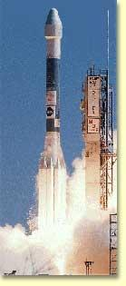 | Delta rocket similar to the one that launched the Deep Space 1 spacecraft from Cape Canaveral, Florida, in October 1998.
The rocket that launched Deep Space 1 on October 24, 1998, had four different kinds of engines. Some pushed the rocket off the ground. Then some helped it continue its climb into space. Others gave the Deep Space 1 spacecraft its final push away from Earth. But all of them forced a gas to shoot out of the rocket, thus pushing the rocket the other way.
We call this wonderful and useful fact the law of action and reaction. The action is the gas rushing out of the rocket. The reaction is the rocket taking off in the other direction. In other words, for every action there is an equal and opposite reaction. The rocket goes in the opposite direction from the gas, and the faster the gas leaves the rocket, the faster the rocket gets pushed the other way.

