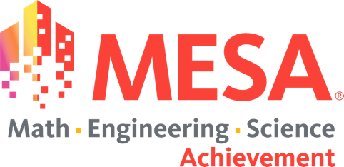

Moon Base
One-Page Information Sheet
2023-2024

LEVEL: Middle School (MS) & High School (HS)

DIVISION(S): Grades 6 and 7/8 & Grades 9/10 and 11/12

CHANGES MADE:
- We specified two openings, instead of doorways, as the cuts can be made anywhere on the structure.
- We expanded the kinds of paint that can be used for testing/judging. Check with your local Center to see what they will be using.
- The Engineering Lab Book is now worth 25% of the final score. If teams fail to submit an Engineering Lab Book, they will not be eligible to place.
  - Engineering Lab Book Guidelines

VIDEO RESOURCES:
- MARS: Video Link
The Curriculum breaks down the five elements.
- Materials. It breaks down Material Sciences and Engineering.
- Weight of Structure vs Impact
- Understanding Cardboard
- Learning from the Past: Now we have pictures!
Introduction and Overview of the Project
- Activities that will help break down and understand the rules in a way where students and advisors can keep track.
  - For example, “Finding Key Words Activity” or “Problem Analysis Activity” Provides students a basic understanding of the rules before they get deeper into it.
- How To Create a Safe Zone Measuring Tool: Video Link

- Train the Judge’s Video: Video Link

- Live Northern California Judge’s Video: Video Link

GENERAL RESOURCES:
- MESA Day Q&A Submission: Link
  - If you have any questions about any MESA Day competitions, use link above.
- MESA Day Q&A Database: Link
  - If you used the MESA Day Q&A Submission link to ask any question about any MESA Day competition, you can use this link to view the answers.

